MACH4METAL

metalworking machinery
Transito 21, 6909 DA Babberich, Netherlands
Tel. + 31 (0)316 – 247123
Fax. + 31 (0)316 - 247956
info@mach4metal.com
www.mach4metal.com
Bank No : 66.52.13.883
IBAN : NL33 INGB 0665 2138 83
BIC : INGBNL2A
VAT : NL 815393635B01

CNC DEGEN Deep hole bore twin spil

- Make : DEGEN Germany
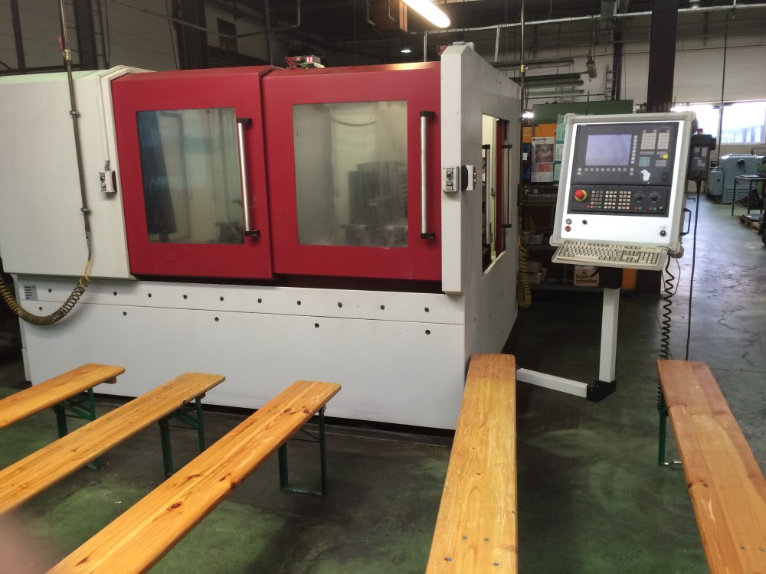
- Type : UTB 400 - 2
- Age : 2006
- Mach : 117

- X – travel Quer : 750
- Y – travel Vert : 630
- Z – travel : 300
- Pinole : 500
- Drilling depth : 900

- Table size. 1.100 x 650 mm
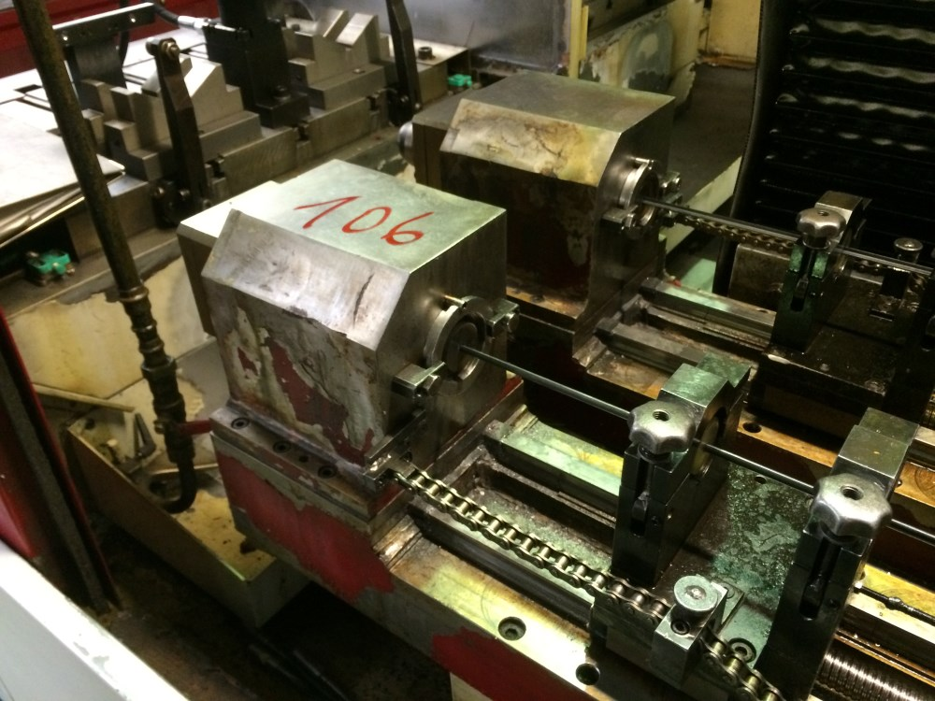
- Rotation 360° Gr. by hand
- Max. 2 to load on table
- Spindle: Mk 2 / Ø 35 mm
- Angle rotation spil + / - 20 Gr.

- Drilling capacity:
- Min. : 4
- Max. :25

- RSF Z 603 CRT controll
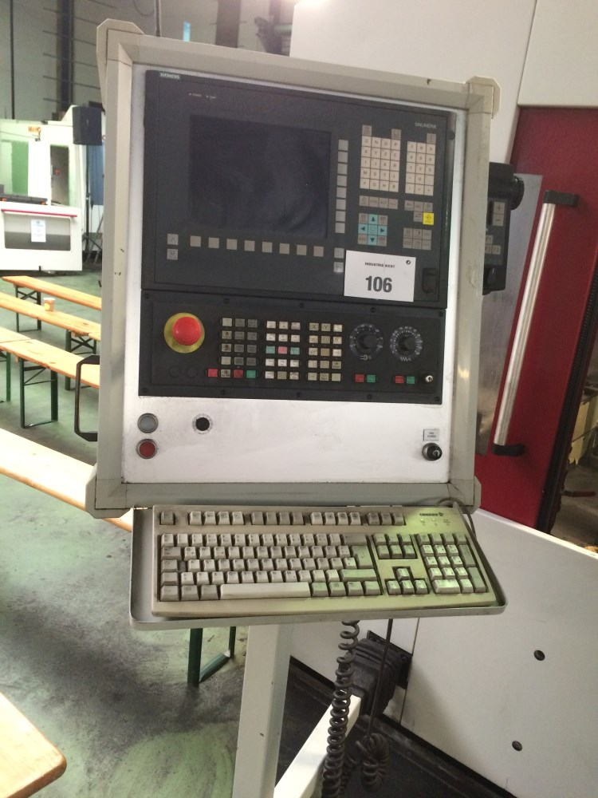
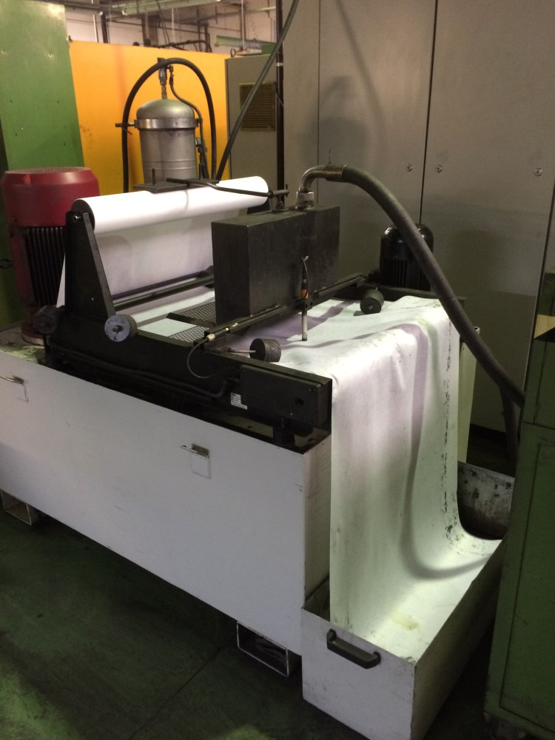
- X – Feed: 0,05 – 100 mm/min.
- Y – Feed: 0,05 – 120 mm/min.
- Spindle : 0 – 3.000 rpm.

- Extra heavy drilling spindle
- Extra heavy feed axis
- Many tooling

Please Note: The above information has been obtained to the best of our ability and belief from, and from the manufacturers where possible. It is given in good faith, but its accuracy can not be guaranteed. Accordingly, it will not form a representation or constitute contractual terms. We advise you to check any vital details!

